Temperature
# Source: AI Source: Provided by: [Data Path: Persons Table -> ID Column: 1, Name_En Column: Motasem Essam] -> From: [ChatGPT] on [7/17/2026]
Temperature is the measurement of the degree of hotness or coldness of an object or substance. It reflects the average kinetic energy of the particles (atoms or molecules) within a material. Temperature is a fundamental physical quantity used in science, engineering, medicine, meteorology, manufacturing, and everyday life.
In the International System of Units (SI), the base unit of thermodynamic temperature is the kelvin (K).

Definition
# Source: AI Source: Provided by: [Data Path: Persons Table -> ID Column: 1, Name_En Column: Motasem Essam] -> From: [ChatGPT] on [7/17/2026]
Temperature is the physical quantity that indicates the thermal state of a body and determines the direction of heat transfer between objects.
Heat naturally flows from an object at a higher temperature to one at a lower temperature until thermal equilibrium is reached.

Purpose
# Source: AI Source: Provided by: [Data Path: Persons Table -> ID Column: 1, Name_En Column: Motasem Essam] -> From: [ChatGPT] on [7/17/2026]
Temperature measurement is used to:
- Determine how hot or cold an object is.
- Monitor industrial and chemical processes.
- Diagnose medical conditions.
- Forecast weather.
- Control heating and cooling systems.
- Ensure food safety.
- Conduct scientific experiments.

SI Unit
# Source: AI Source: Provided by: [Data Path: Persons Table -> ID Column: 1, Name_En Column: Motasem Essam] -> From: [ChatGPT] on [7/17/2026]
The SI base unit of thermodynamic temperature is:
1 kelvin (K)
The kelvin is defined by fixing the numerical value of the Boltzmann constant.

Common Temperature Units
# Source: AI Source: Provided by: [Data Path: Persons Table -> ID Column: 1, Name_En Column: Motasem Essam] -> From: [ChatGPT] on [7/17/2026]

Unit | Symbol | Common Use
Kelvin | K | Scientific measurements (SI)
Degree Celsius | °C | Everyday use, weather, medicine
Degree Fahrenheit | °F | Commonly used in the United States

Temperature Conversion

Celsius and Kelvin
# Source: AI Source: Provided by: [Data Path: Persons Table -> ID Column: 1, Name_En Column: Motasem Essam] -> From: [ChatGPT] on [7/17/2026]
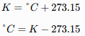
$$K=°C+273.15 \\ °C=K-273.15$$

Celsius and Fahrenheit
# Source: AI Source: Provided by: [Data Path: Persons Table -> ID Column: 1, Name_En Column: Motasem Essam] -> From: [ChatGPT] on [7/17/2026]
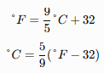
$$°F=\frac{9}{5}°C+32 \\ °C=\frac{5}{9}(°F-32)$$

Fahrenheit and Kelvin
# Source: AI Source: Provided by: [Data Path: Persons Table -> ID Column: 1, Name_En Column: Motasem Essam] -> From: [ChatGPT] on [7/17/2026]
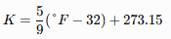
$$K=\frac{5}{9}(°F-32)+273.15$$

Measuring Instruments
# Source: AI Source: Provided by: [Data Path: Persons Table -> ID Column: 1, Name_En Column: Motasem Essam] -> From: [ChatGPT] on [7/17/2026]
Temperature is commonly measured using:
- Mercury thermometer
- Alcohol thermometer
- Digital thermometer
- Infrared thermometer
- Thermocouple
- Resistance Temperature Detector (RTD)
- Thermistor
- Bimetallic thermometer

Measurement Process
# Source: AI Source: Provided by: [Data Path: Persons Table -> ID Column: 1, Name_En Column: Motasem Essam] -> From: [ChatGPT] on [7/17/2026]
To measure temperature:
- Select an appropriate thermometer or sensor.
- Place it in thermal contact with the object or environment.
- Allow sufficient time for thermal equilibrium.
- Read the indicated value.
- Record the measurement with the correct unit.

Examples
# Source: AI Source: Provided by: [Data Path: Persons Table -> ID Column: 1, Name_En Column: Motasem Essam] -> From: [ChatGPT] on [7/17/2026]
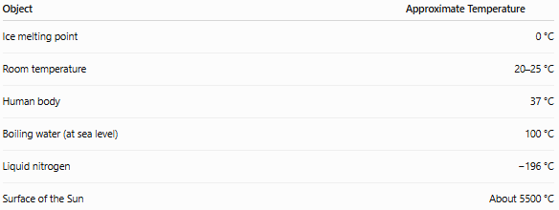
Object | Approximate Temperature
Ice melting point | 0 °C
Room temperature | 20–25 °C
Human body | 37 °C
Boiling water (at sea level) | 100 °C
Liquid nitrogen | −196 °C
Surface of the Sun | About 5500 °C

Accuracy
# Source: AI Source: Provided by: [Data Path: Persons Table -> ID Column: 1, Name_En Column: Motasem Essam] -> From: [ChatGPT] on [7/17/2026]
Accurate temperature measurement depends on:
- Proper sensor selection.
- Good thermal contact.
- Instrument calibration.
- Stable environmental conditions.
- Allowing thermal equilibrium before reading.

Precision
# Source: AI Source: Provided by: [Data Path: Persons Table -> ID Column: 1, Name_En Column: Motasem Essam] -> From: [ChatGPT] on [7/17/2026]
Precision refers to the consistency of repeated temperature measurements.
Example:
- 24.98 °C
- 25.00 °C
- 24.99 °C
These measurements are highly precise.

Applications
# Source: AI Source: Provided by: [Data Path: Persons Table -> ID Column: 1, Name_En Column: Motasem Essam] -> From: [ChatGPT] on [7/17/2026]
Temperature measurement is essential in:
- Physics
- Chemistry
- Biology
- Medicine
- Meteorology
- Manufacturing
- Food processing
- Refrigeration
- Electronics
- Environmental science

Everyday Importance
# Source: AI Source: Provided by: [Data Path: Persons Table -> ID Column: 1, Name_En Column: Motasem Essam] -> From: [ChatGPT] on [7/17/2026]
Temperature measurement is used daily for:
- Weather forecasts.
- Body temperature checks.
- Cooking and baking.
- Air conditioning.
- Refrigeration.
- Water heating.
- Industrial process control.
- Vehicle engine monitoring.

Common Mistakes
# Source: AI Source: Provided by: [Data Path: Persons Table -> ID Column: 1, Name_En Column: Motasem Essam] -> From: [ChatGPT] on [7/17/2026]
- Confusing temperature with heat.
- Using the wrong temperature scale.
- Reading a thermometer before thermal equilibrium.
- Measuring outside the instrument's operating range.
- Ignoring calibration requirements.

Key Points
# Source: AI Source: Provided by: [Data Path: Persons Table -> ID Column: 1, Name_En Column: Motasem Essam] -> From: [ChatGPT] on [7/17/2026]
- Temperature measures the degree of hotness or coldness of a body.
- It is related to the average kinetic energy of particles.
- The SI base unit is the kelvin (K).
- Common practical scales are Celsius (°C) and Fahrenheit (°F).
- Temperature is measured using thermometers and temperature sensors.
- Heat flows naturally from higher temperature to lower temperature.

Temperature vs. Heat
# Source: AI Source: Provided by: [Data Path: Persons Table -> ID Column: 1, Name_En Column: Motasem Essam] -> From: [ChatGPT] on [7/17/2026]
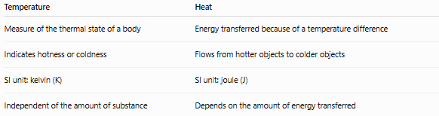
Temperature | Heat
Measure of the thermal state of a body | Energy transferred because of a temperature difference
Indicates hotness or coldness | Flows from hotter objects to colder objects
SI unit: kelvin (K) | SI unit: joule (J)
Independent of the amount of substance | Depends on the amount of energy transferred

Temperature vs. Thermal Energy
# Source: AI Source: Provided by: [Data Path: Persons Table -> ID Column: 1, Name_En Column: Motasem Essam] -> From: [ChatGPT] on [7/17/2026]
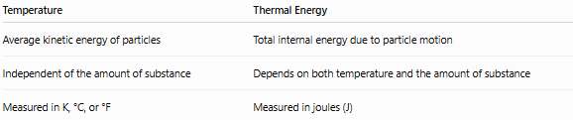
Temperature | Thermal Energy
Average kinetic energy of particles | Total internal energy due to particle motion
Independent of the amount of substance | Depends on both temperature and the amount of substance
Measured in K, °C, or °F | Measured in joules (J)

Temperature vs. Thermodynamic Temperature
# Source: AI Source: Provided by: [Data Path: Persons Table -> ID Column: 1, Name_En Column: Motasem Essam] -> From: [ChatGPT] on [7/17/2026]
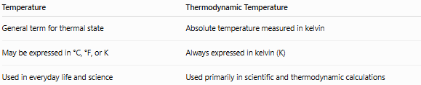
Temperature | Thermodynamic Temperature
General term for thermal state | Absolute temperature measured in kelvin
May be expressed in °C, °F, or K | Always expressed in kelvin (K)
Used in everyday life and science | Used primarily in scientific and thermodynamic calculations

Conclusion
# Source: AI Source: Provided by: [Data Path: Persons Table -> ID Column: 1, Name_En Column: Motasem Essam] -> From: [ChatGPT] on [7/17/2026]
Temperature is the measurement of the degree of hotness or coldness of a substance and is directly related to the average kinetic energy of its particles. It is one of the seven SI base quantities, with the kelvin (K) as its standard unit. Common practical scales include Celsius (°C) and Fahrenheit (°F). Accurate temperature measurement, using properly calibrated thermometers or sensors, is essential in science, engineering, medicine, meteorology, manufacturing, food safety, and countless everyday applications.

